Practical - 2

Aim:
Implement functions to print nth Fibonacci number using iteration and recursive methods. Compare the performance of two methods by counting the number of steps executed on various inputs. Also draw a comparative chart. (Fibonacci series 1, 1, 2, 3, 5, 8….. Here 8 is the 6th Fibonacci number)

Code:

#include <stdio.h>

int count_ite = 0;
int count_rec = 0;

int fib_ite_142(int n) {
if (n <= 1) {
count_ite++;
return n;
}
else {
int t1 = 0, t2 = 1, nextTerm;
for (int i = 1; i < n; ++i) {
count_ite++;
nextTerm = t1 + t2;
t1 = t2;
t2 = nextTerm;
}
return nextTerm;
}
}

int fib_rec_142(int n) {
if (n <= 1) {
count_rec++;
return n;
}
else {
count_rec++;
return fib_rec_142(n - 1) + fib_rec_142(n - 2);
}
}

int main() {
int n;
printf("\nEnter Number to find Fibonacci Value: ");
scanf("%d", &n);
int result_ite = fib_ite_142(n);
printf("\n------------------------------------------");
printf("\nEnroll Number: 142");
printf("\nLoop Method");
printf("\nFibonacci of Number %d is: %d", n, result_ite);
printf("\nCount of Step of Algorithm is : %d", count_ite);
printf("\n------------------------------------------");
int result_rec = fib_rec_142(n);
printf("\n------------------------------------------");
printf("\nEnroll Number: 142");
printf("\nRecursive Method");
printf("\nFibonacci of Number %d is: %d", n, result_rec);
printf("\nCount of Step of Algorithm is : %d", count_rec);
printf("\n------------------------------------------");
return 0;
}

Output:
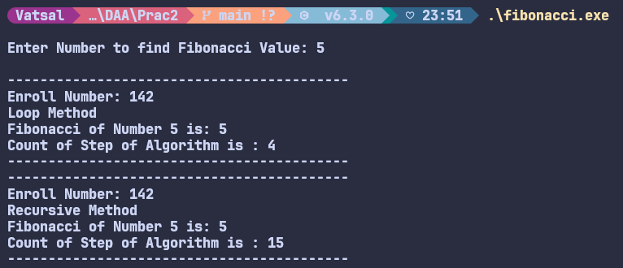

Analysis:
Value of N | Steps in iteration method | Steps in recursive method
3 | 2 | 5
5 | 4 | 15
6 | 5 | 25
7 | 6 | 41
10 | 9 | 177
15 | 14 | 1973

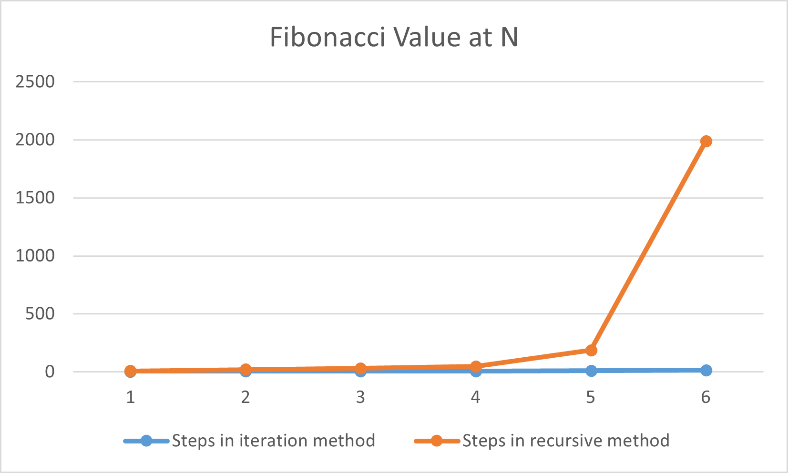
Conclusion:
- The program contrasts iterative and naive recursive Fibonacci implementations.
- The iterative approach runs in O(n) time with O(1) space, updating two variables per step.
- The recursive version here has exponential time due to repeated subproblem calls, making it impractical for larger n.
- Recursive calls add overhead and can risk deep call stacks, while iteration avoids these costs.
- Step counts clearly show the iterative method scales predictably and efficiently.
- If recursion is desired, use memoization or dynamic programming to eliminate recomputation.

